Module Assembly - TC API - Port UnifiedSubmissionValidator Logic For Analyzing Submitted File Deployment Guide

Revision History
Author | Revision Number | Date
isv | 1.0 | 04/18/2014

Deployment Instructions 3
1. Organization of Submission 3
2. Application Setup 3
2.1 Configuration 3
2.2 Build Scripts Setup 4
3. Database Setup 4
4. Deployment Instructions 4
5. Starting 4
6. Verification 4
7. Resource Contact List 7

Deployment Instructions

Organization of Submission

The submission follows directory structure provided below:

docs

Contains this document which is the Deployment Guide for the Module Assembly - TC API -Port UnifiedSubmissionValidator Logic For Analyzing Submitted File assembly.

tc-api

Contains the configuration, libraries, sources for TopCoder Node JS API application developed/updated in the course of this assembly. This directory replicates the application development distribution structure and includes only updated and new files.

Application Setup

The submission is expected to be deployed to the following environment:

JRE 1.7
NodeJS 0.10.21
Informix DS 11.0
Git
Python 2.7.6
Heroku

This assembly was developed against following Git commit hash:

URL: https://github.com/cloudspokes/tc-api.git
Hash: 337c5d1a21f0030e75fae97109d5161c2307d48c

Configuration

Following new configuration parameters have been defined by this assembly:

Property Name | File property is stored | Example Setting
designSubmission.sourcePrefix | tc-api/config.js | A prefix for entries in submission archive corresponding to native source files (for example, source/)
designSubmission.submissionPrefix | tc-api/config.js | A prefix for entries in submission archive corresponding to submission and preview files (for example, submission/)

Build Scripts Setup

The TopCoder NodeJS API application provides the following commands which are to be used:

- npm install – installs TopCoder NodeJS API application
- npm rebuild – rebuilds TopCoder NodeJS API application
- npm test – runs Mocha-based unit tests.

Database Setup

No changes to existing database schema have been made.

Deployment Instructions

- Set up necessary infrastructure for TopCoder NodeJS API based on your environment See following page for details (click the link corresponding to your OS):
  - https://github.com/cloudspokes/tc-api/wiki/_pages
- Clone TopCoder NodeJS application from Git repository https://github.com/cloudspokes/tc-api.git to your local machine. See chapters suitable for your local environment at following page for details (click the link corresponding to your OS):
  - https://github.com/cloudspokes/tc-api/wiki/_pages
- Copy the code from tc-api directory of this submission into working copy cloned from Git repository at step above
- Set up environment variables to suit the current environment. See https://github.com/cloudspokes/tc-api/wiki/Configure-Environment-Variables
- Install TopCoder NodeJS API application using npm install command. See chapters suitable for your local environment at https://github.com/cloudspokes/tc-api/wiki/_pages for help (click the link corresponding to your OS)

Starting

- Install the TopCoder NodeJS API application
- Start ActionsHero server instance hosting TopCoder NodeJS API application (see Start Server chapter at page matching your current OS at https://github.com/cloudspokes/tc-api/wiki/_pages)

Verification

- Run the unit tests using command like:

node_modules/.bin/mocha ./test/test.unifiedSubmissionValidator.js

The tests must be executed successfully:

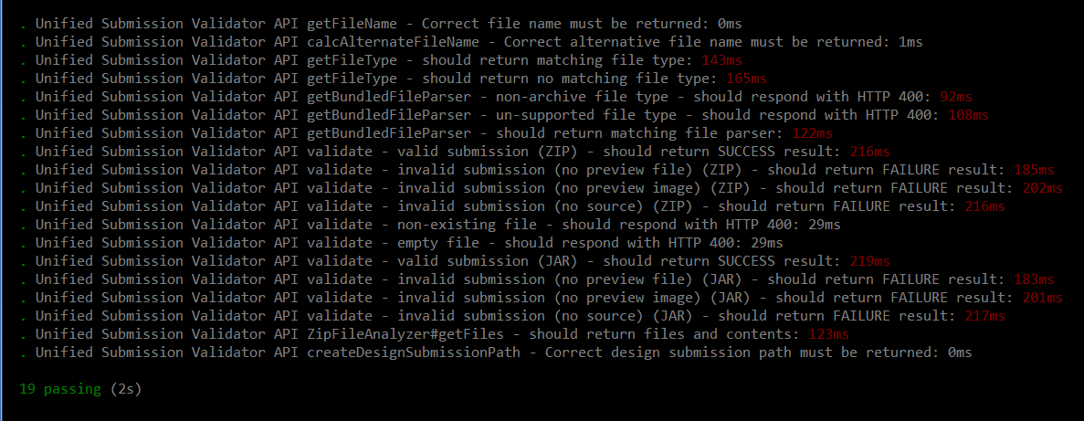

- Setup node-jslint tool using command like npm install jslint -g and check formatting for the updated code using commands like:

jslint --nomen actions/unifiedSubmissionValidatorTest.js
jslint --nomen common/unifiedSubmissionValidator.js
jslint --nomen test/test.unifiedSubmissionValidator.js
jslint --nomen routes.js
jslint --nomen config.js

There must be no code formatting errors displayed:

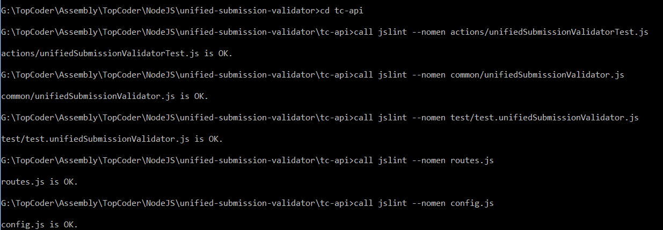

- Open browser window and type an URL like: http://localhost:8080/test/usv/validate?filePath=test/test_files/unified_submission_validator/valid_submission.zip

The test action must respond with correct result based on the provided parameters:

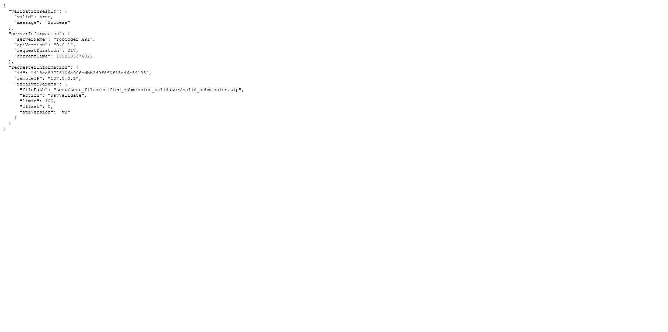

- Open browser window and type an URL like: http://localhost:8080/test/usv/getFileType?fileName=test.txt

The test action must respond with correct result based on the provided parameters:

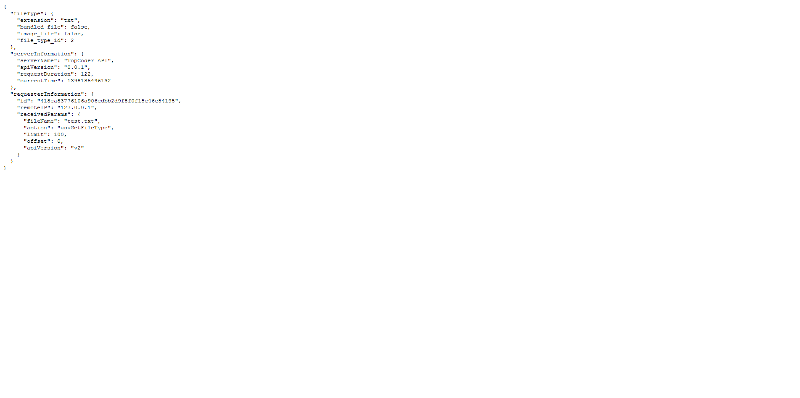

- Open browser window and type an URL like: http://localhost:8080/test/usv/getBundledFileParser?filePath=test.zip

The test action must respond with correct result based on the provided parameters:

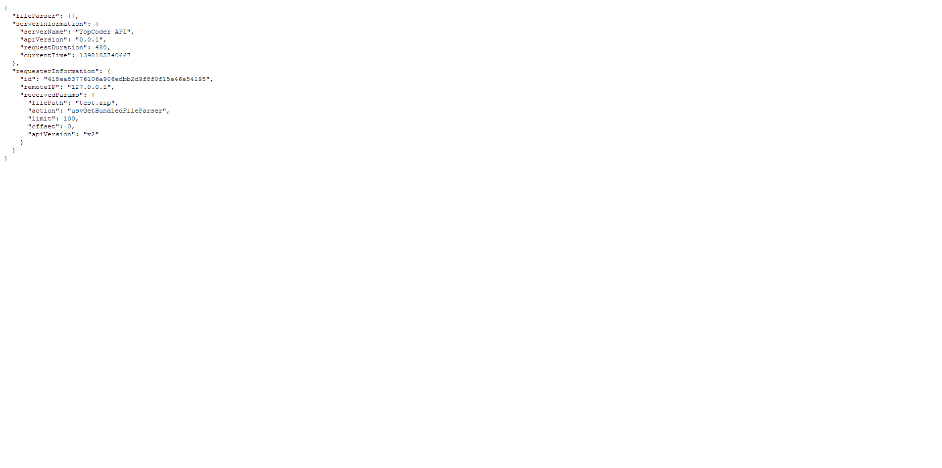

- Open browser window and type an URL like: http://localhost:8080/test/usv/getFiles?filePath=test/test_files/unified_submission_validator/valid_submission.zip

The test action must respond with correct result based on the provided parameters:

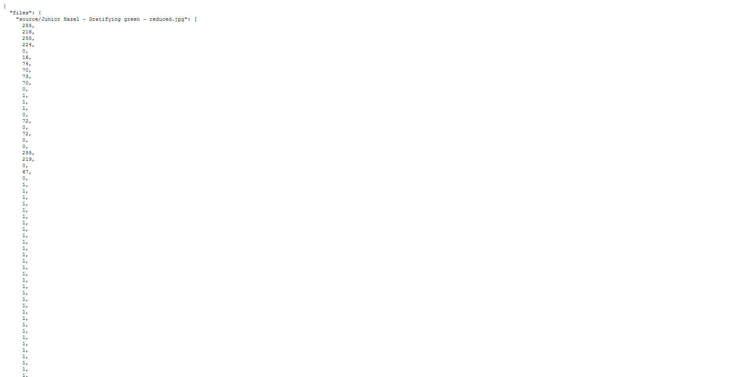

Resource Contact List

Name | Resource Email
isv

